NAME: Ch. Usha sri

ROLL NO: 21481A0223

# **Data Analytics**

Assignment -1

1.Invoice id: Computer-generated sales slip invoice identification number

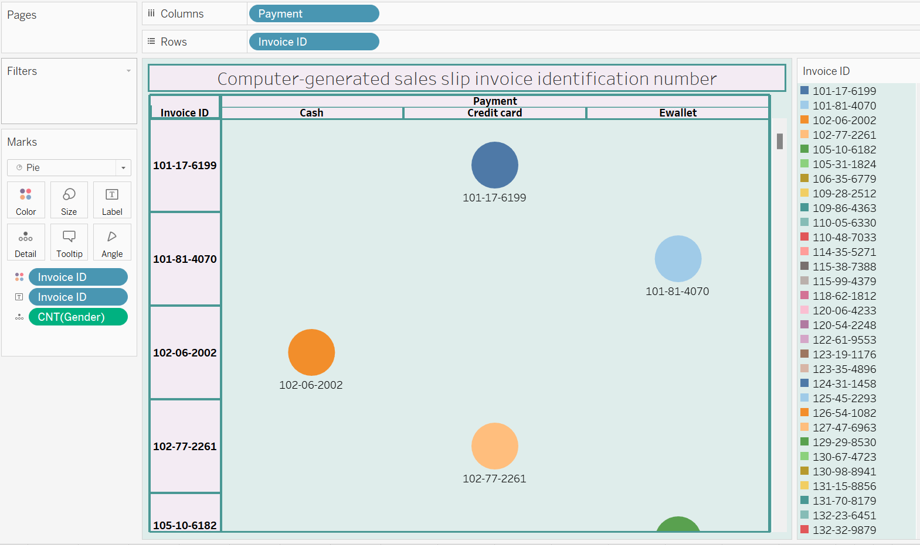

2. Branch: Branch of supercenter (3 branches are available identified by A, B and C).

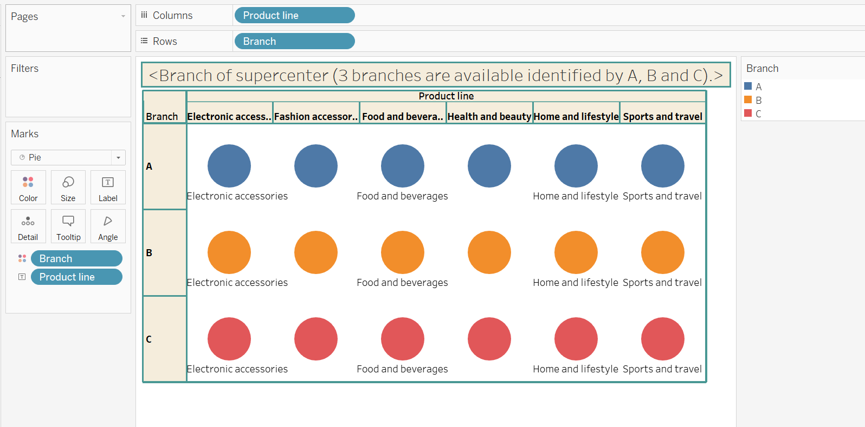

3. City: Location of supercenters

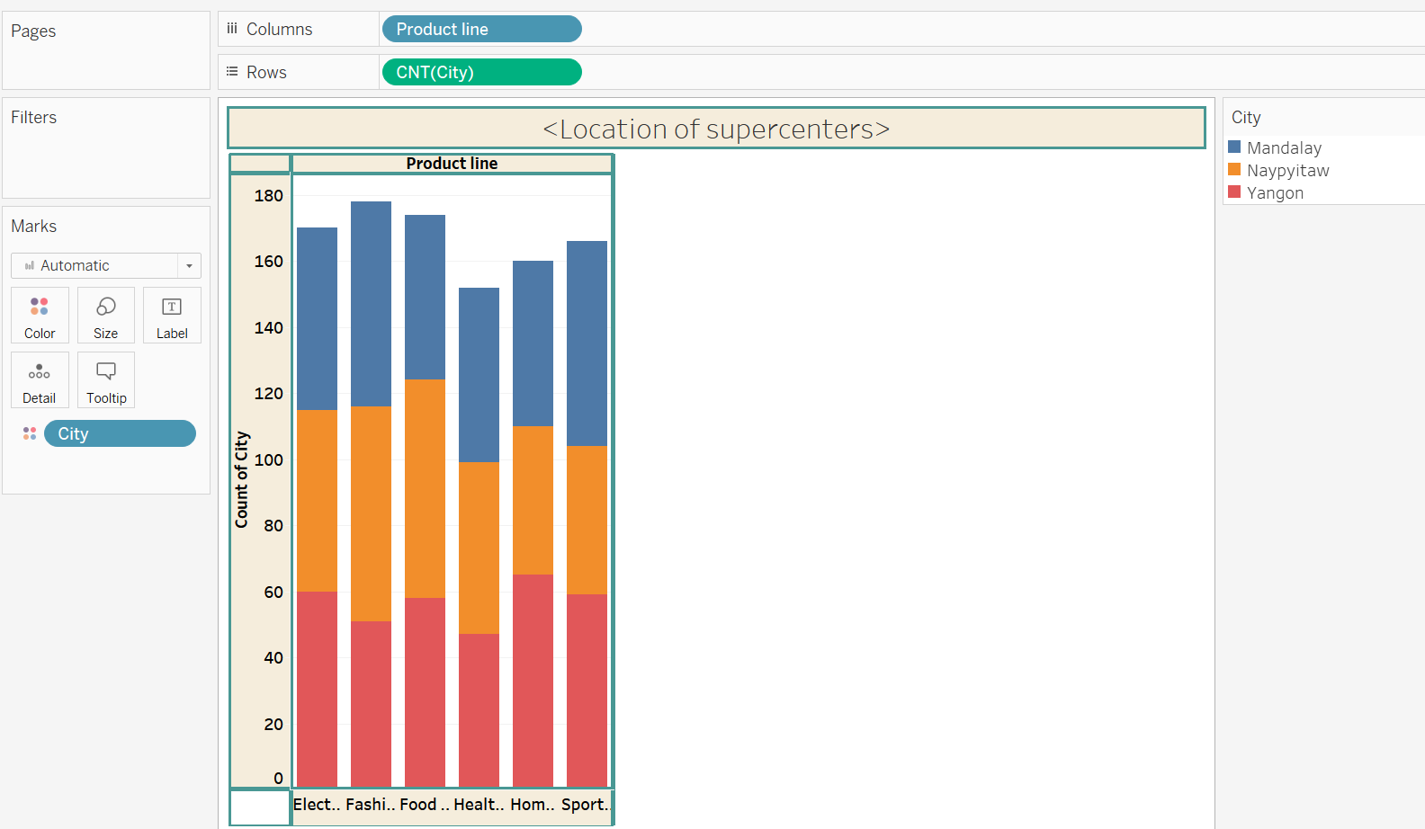

4. Customer type: Type of customers, recorded by Members for customers using member

cards and Normal for those without member cards.

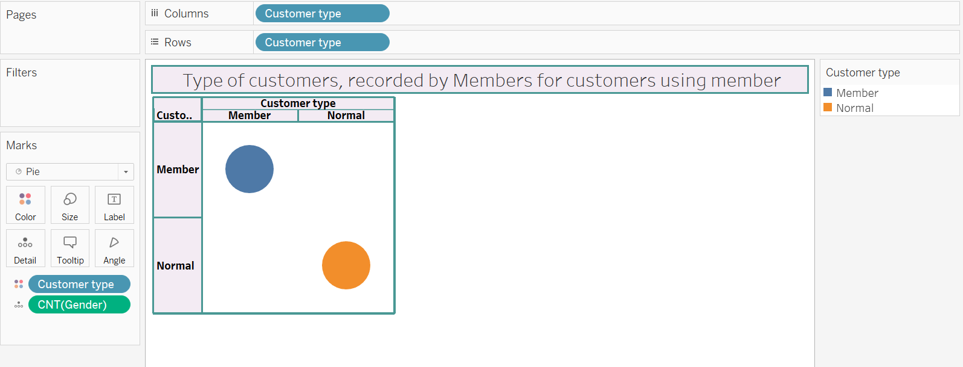

5. Gender: Gender type of customer

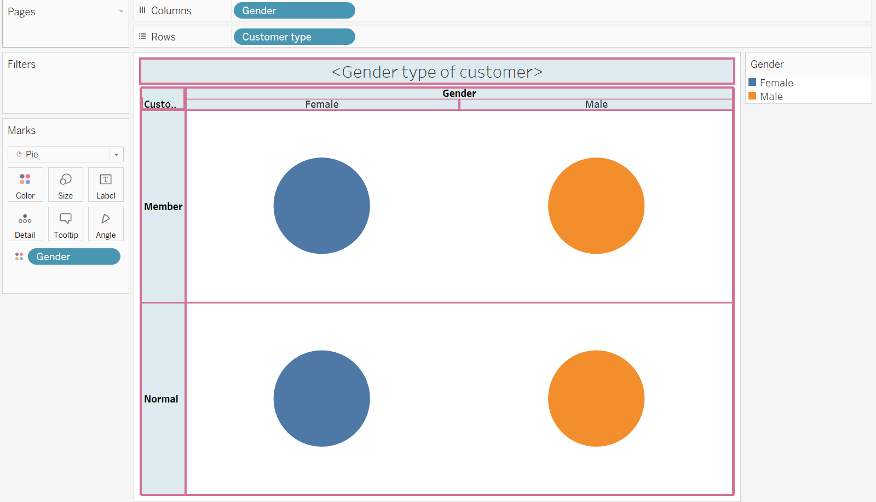

6.Product line: General item categorization groups - Electronic accessories, Fashion

accessories, Food and beverages, Health and beauty, Home and lifestyle, Sports and

travel

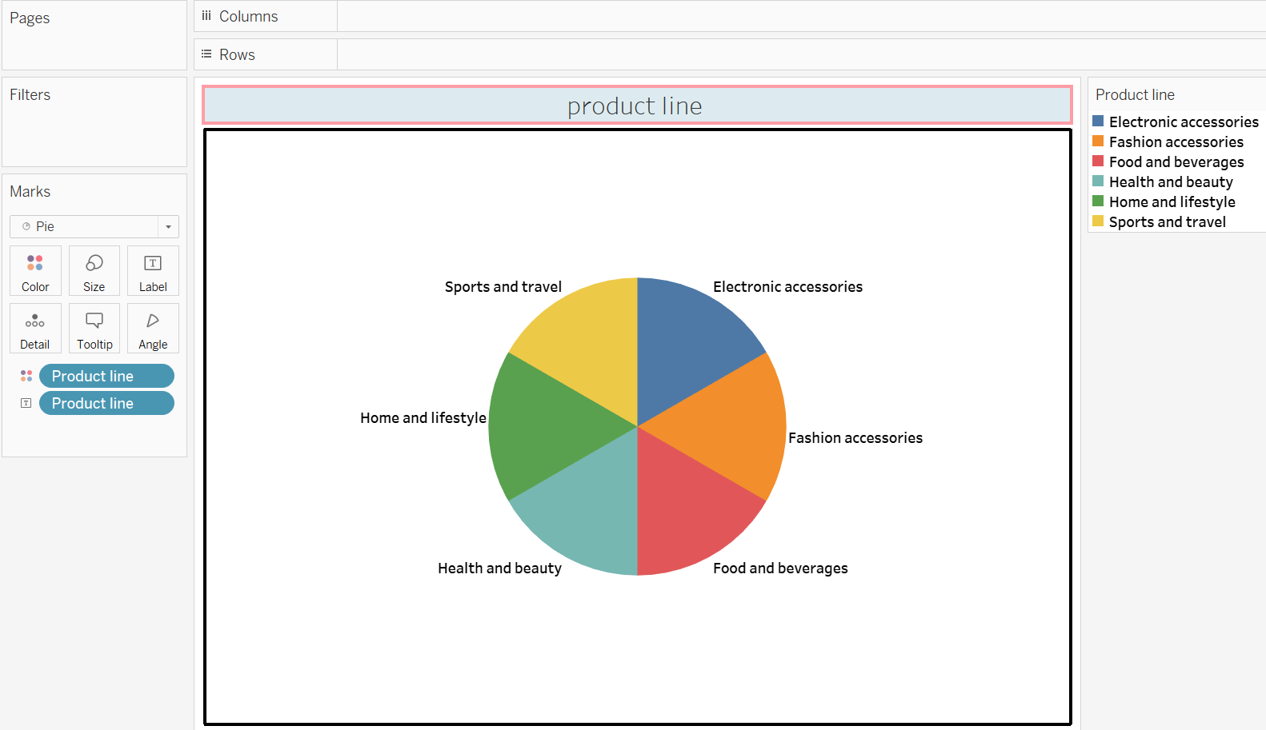

7. Unit price: The price of each product in $

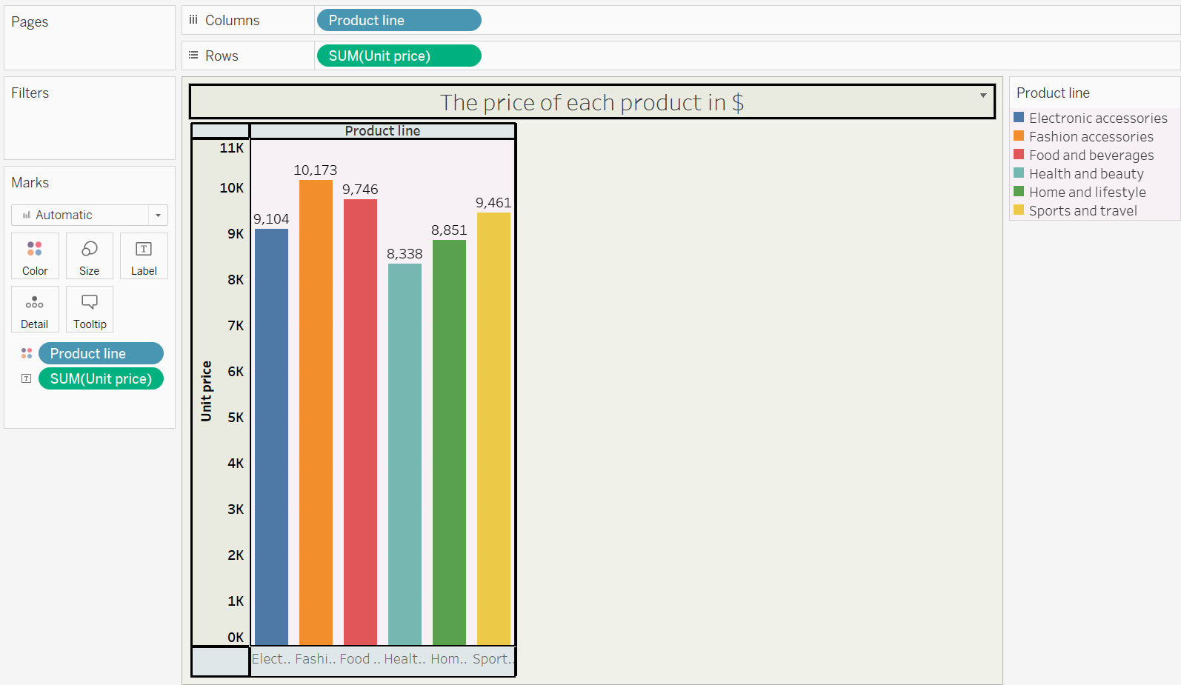

8. Quantity: Number of products purchased by the customer

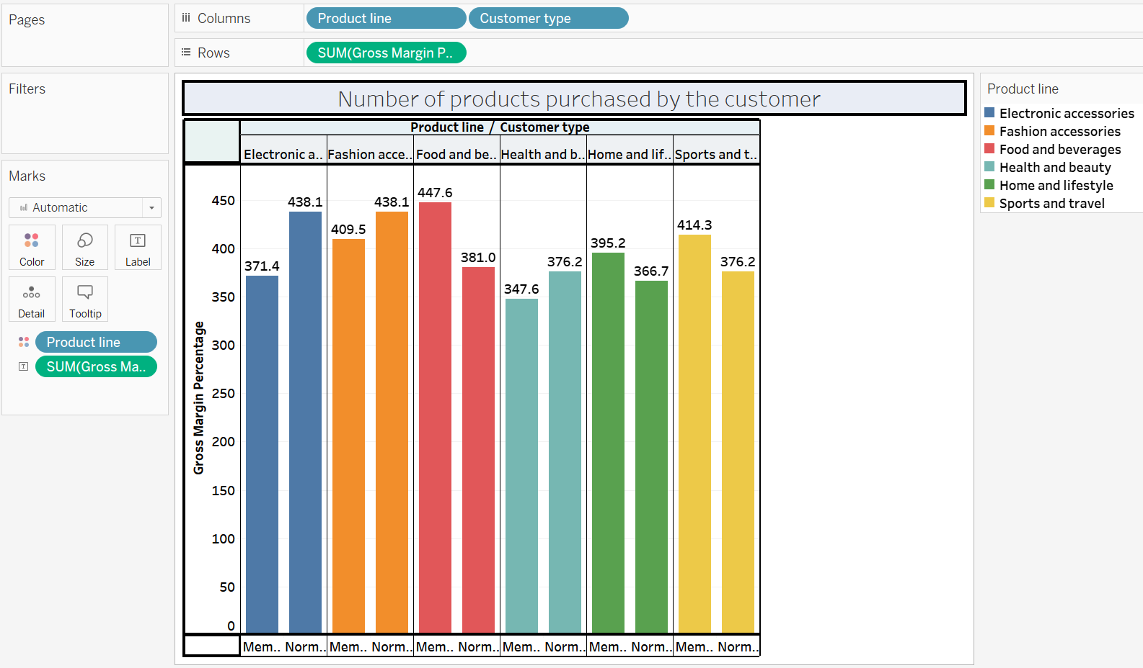

9. Tax: 5% tax fee for customers buying.

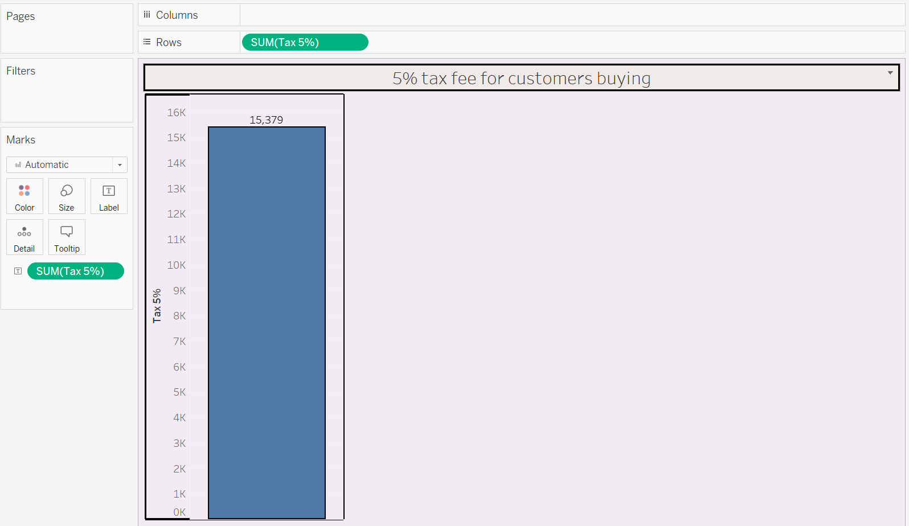

10. Total: Total price including tax

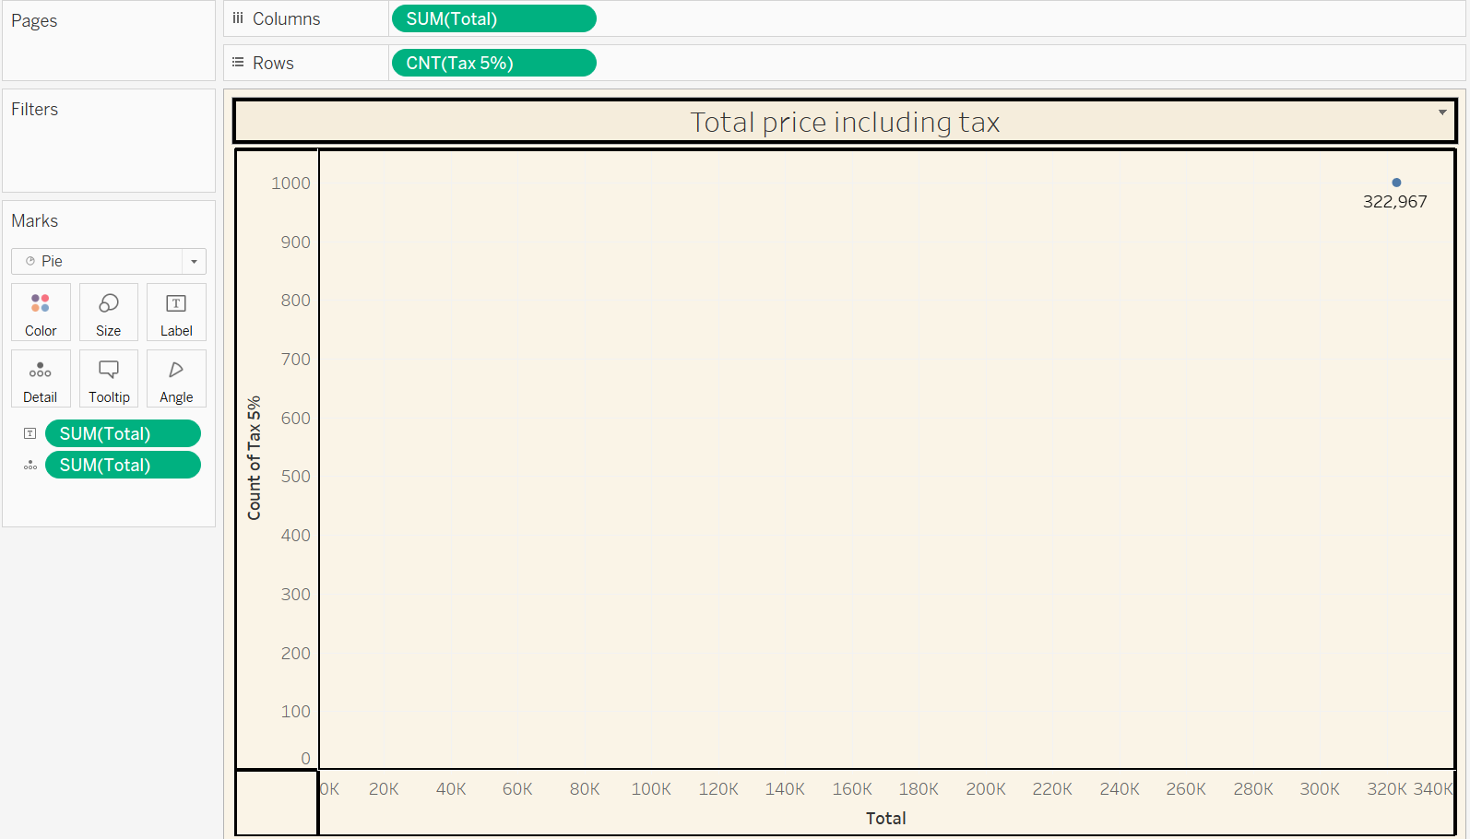

11. Date: Date of purchase (Record available from January 2019 to March 2019)

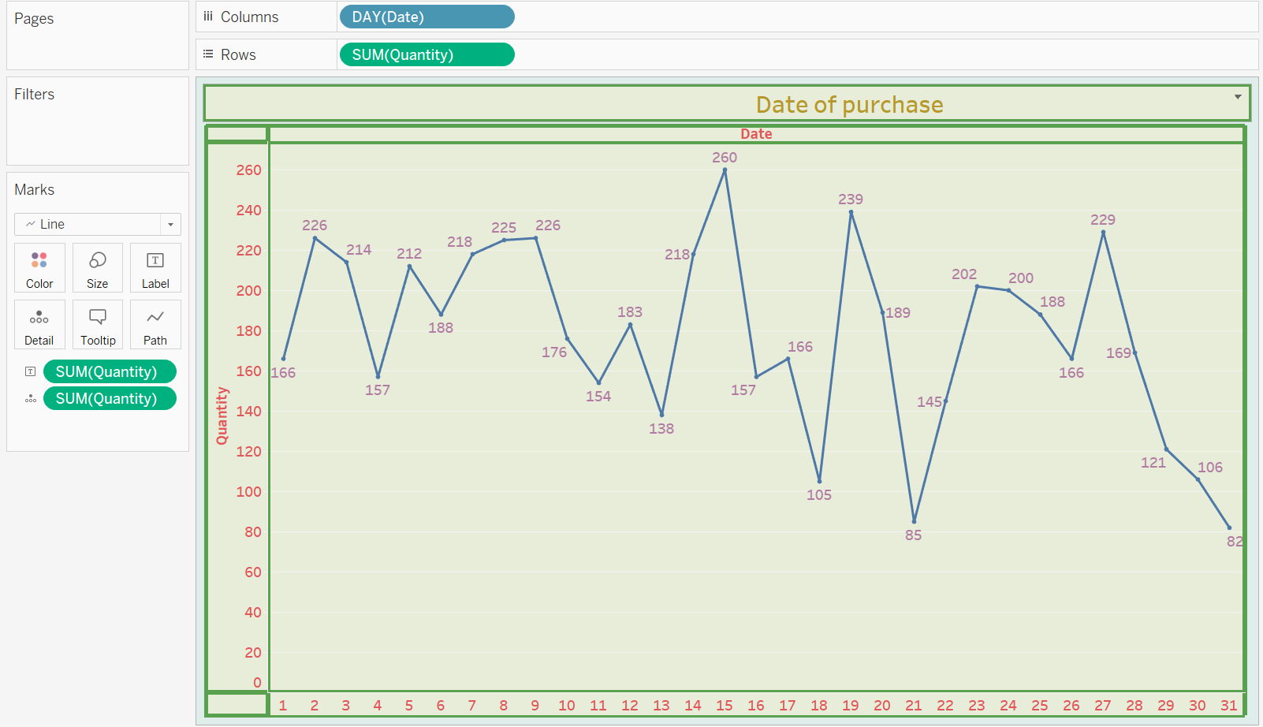

12. Time: Purchase time (10 am to 9 pm)

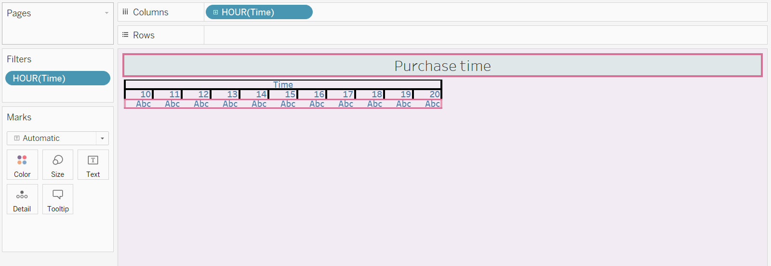

13. Payment: Payment used by the customer for the purchase (3 methods are available –

Cash, Credit card and Ewallet)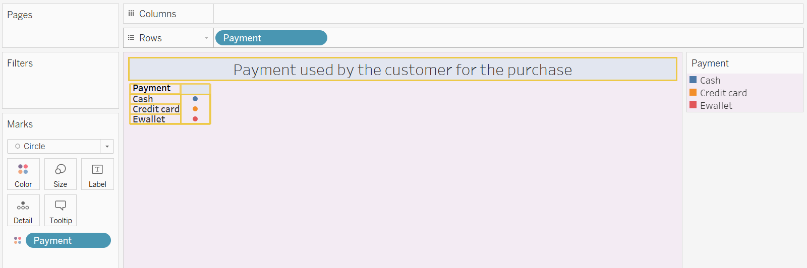

14. COGS: Cost of goods sold

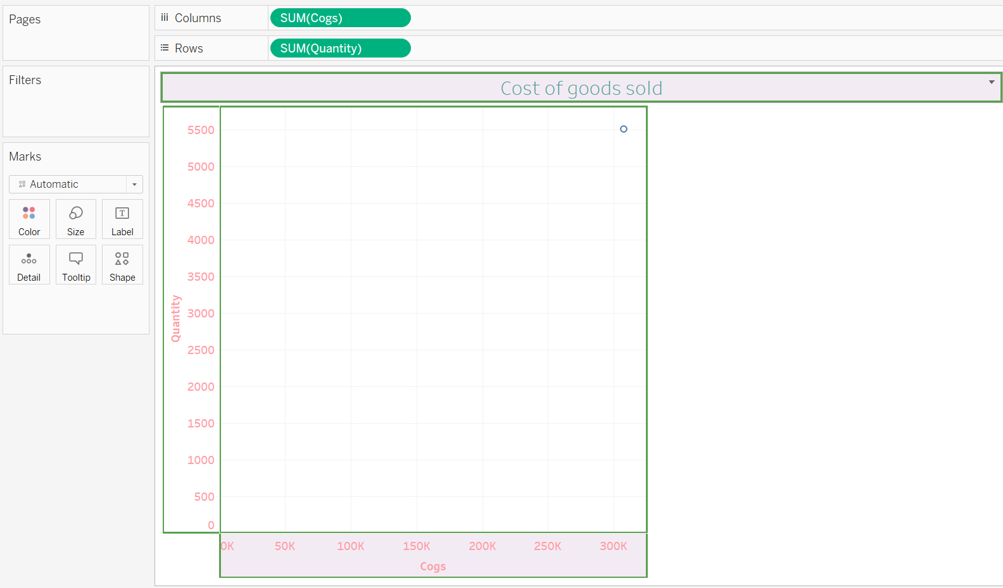

15. Gross margin percentage: Gross margin percentage

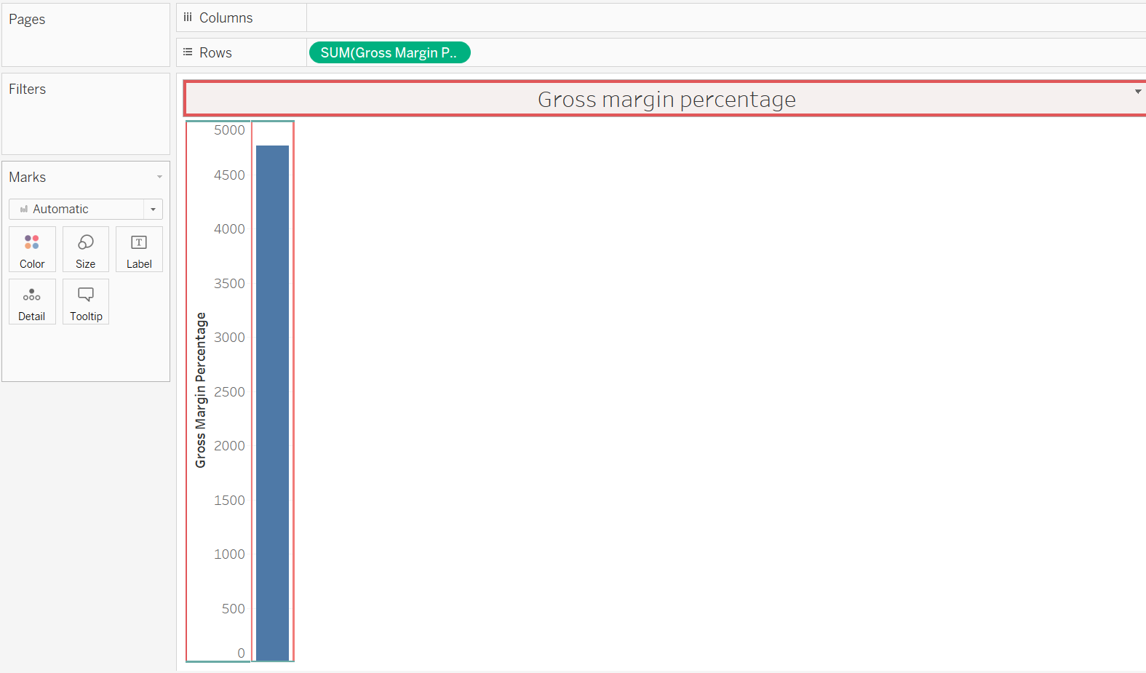

16. Gross income: Gross income

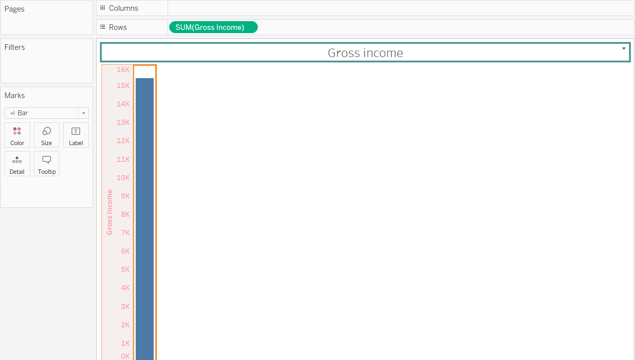

17. Rating: Customer stratification rating on their experience (scale of 1 to 10)

